**Assignment 9.2**

**Working of pig script commands with example:**

* **LOAD**

To Load the data from the file system (local/HDFS) into a relation.

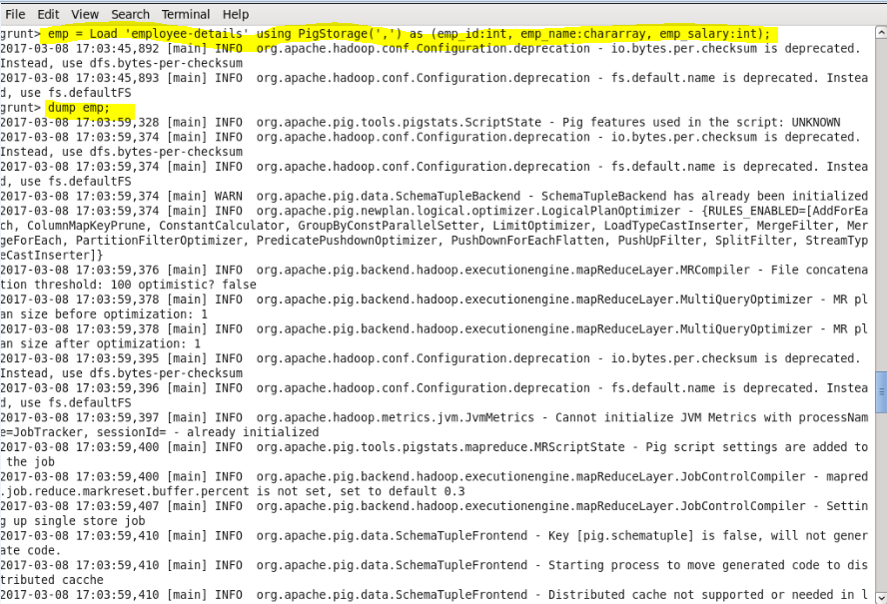

* **STORE**

To save a relation to the file system (local/HDFS).

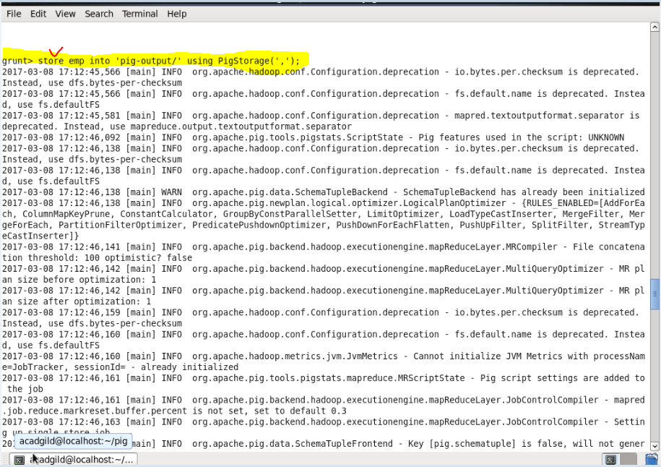 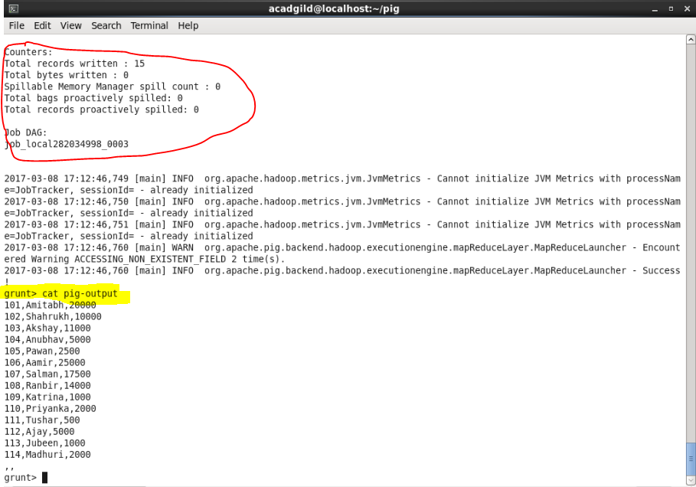

* **DUMP**

To print the contents of a relation on the console.

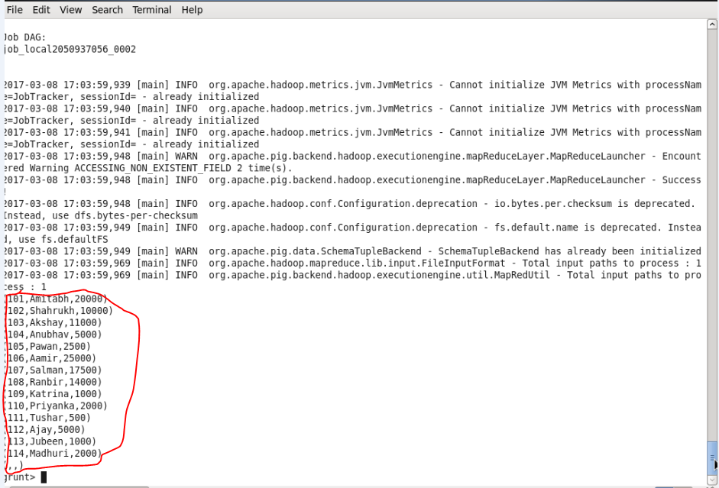

* **FOREACH**

The **FOREACH** operator is used to generate specified data transformations based on the column data.

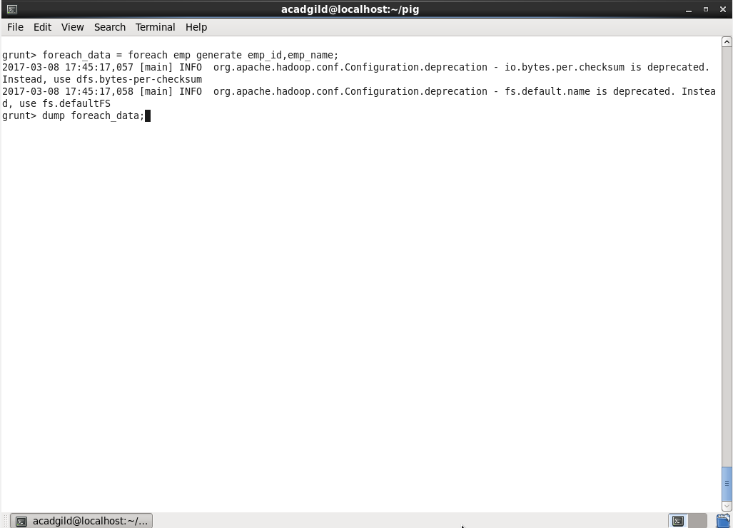

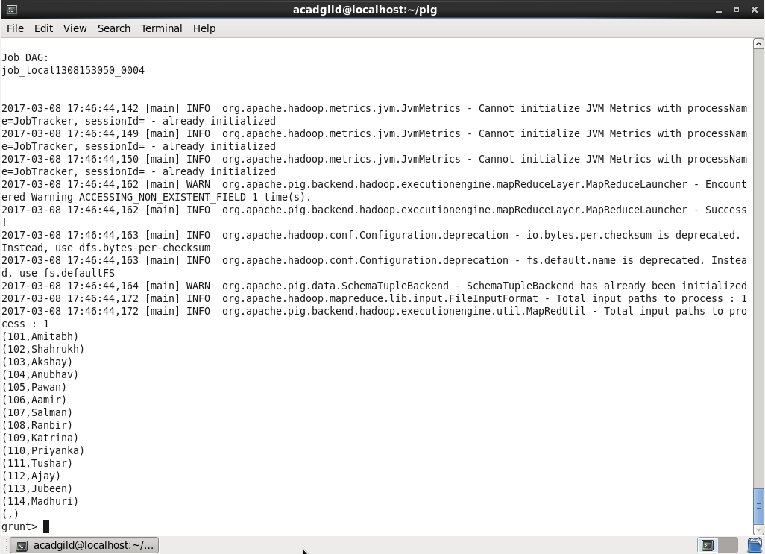

* **FILTER**

The **FILTER** operator is used to select the required tuples from a relation based on a condition.

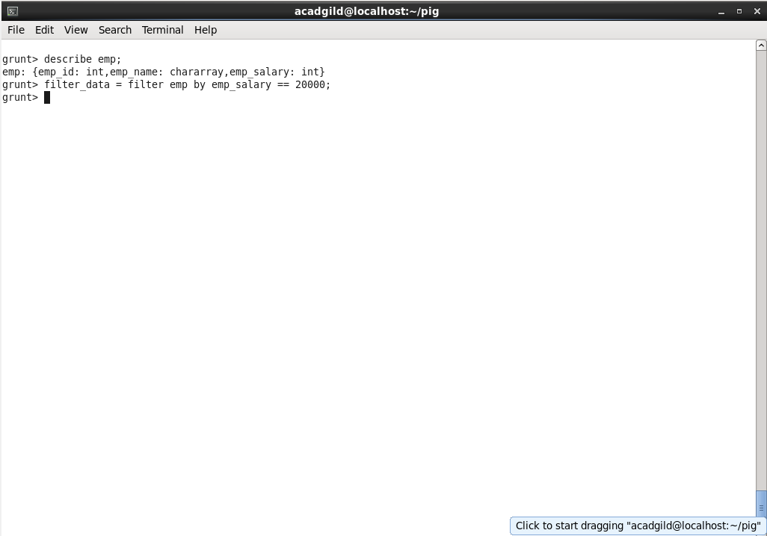

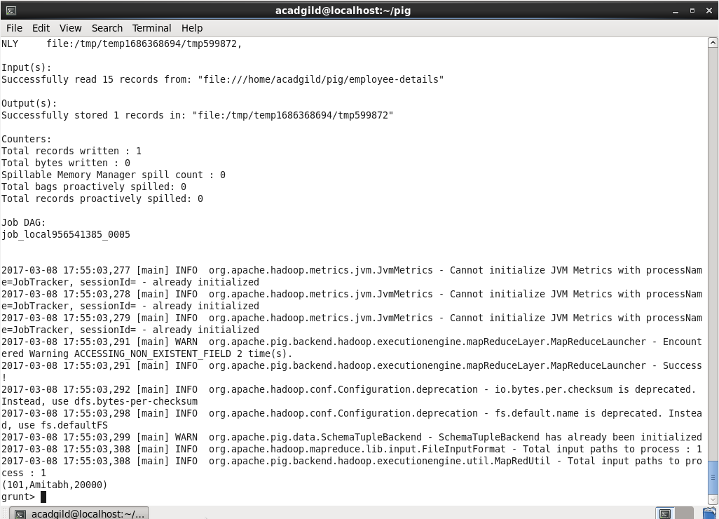

* **GROUP BY**

The **GROUP** operator is used to group the data in one or more relations. It collects the data having the same key.

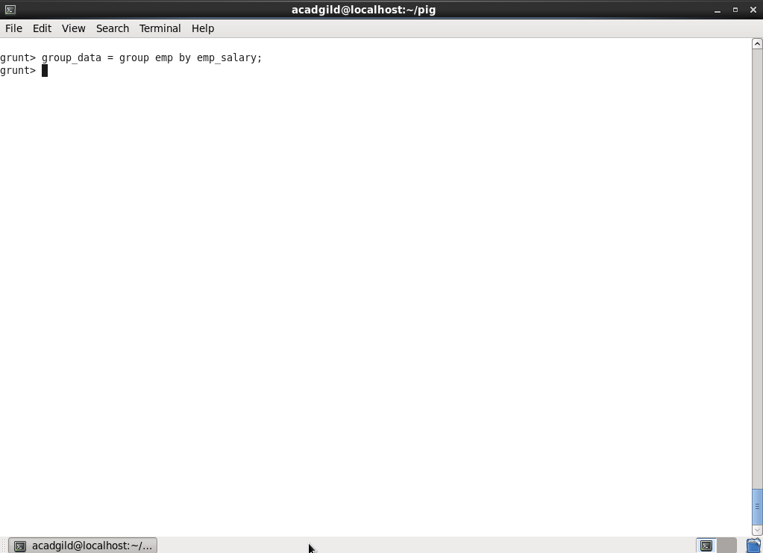

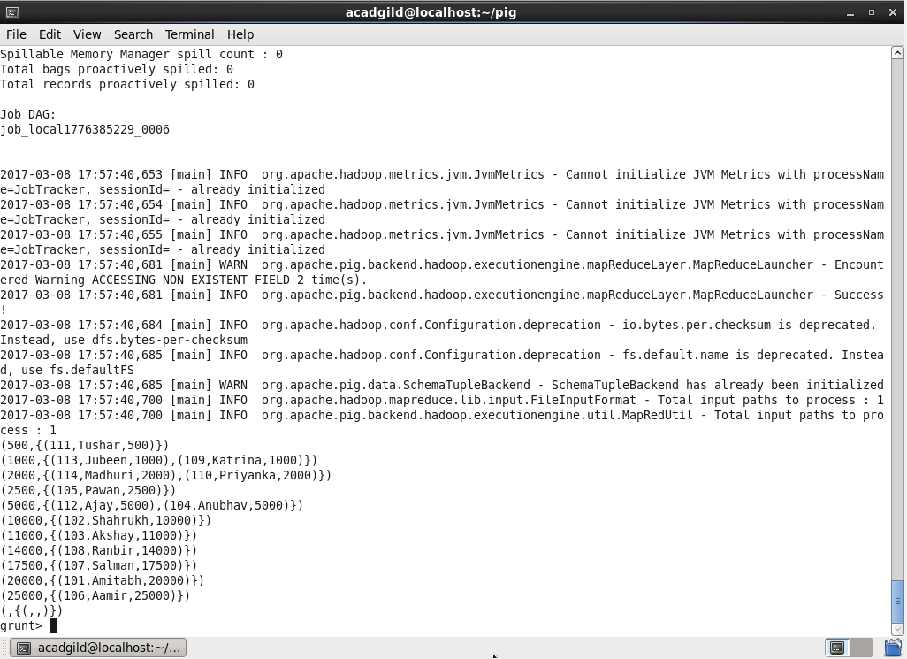

* **ORDER BY**

The **ORDER BY** operator is used to display the contents of a relation in a sorted order based on one or more fields.

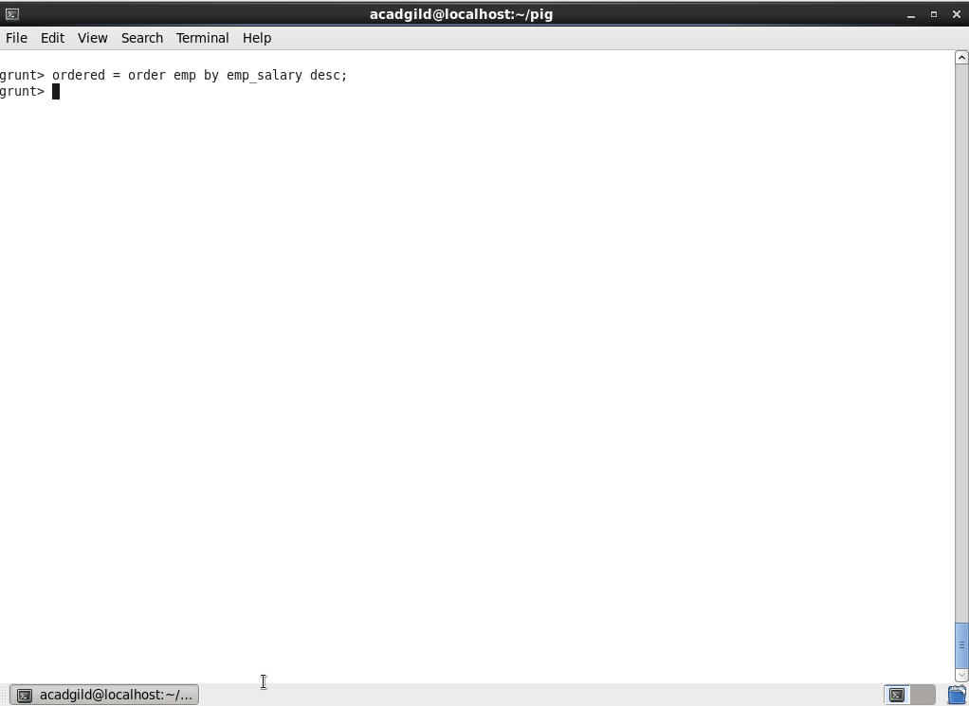

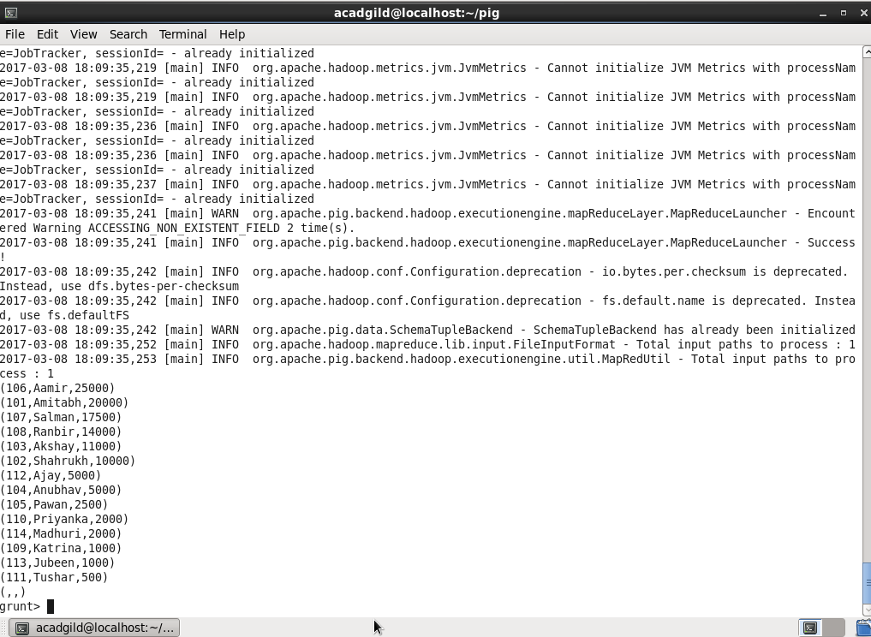

* **DESCRIBE**

The **describe** operator is used to view the schema of a relation.

